SQL Database Creation and Queries
4/9/2026
- Show all students with full names sorted by last name.
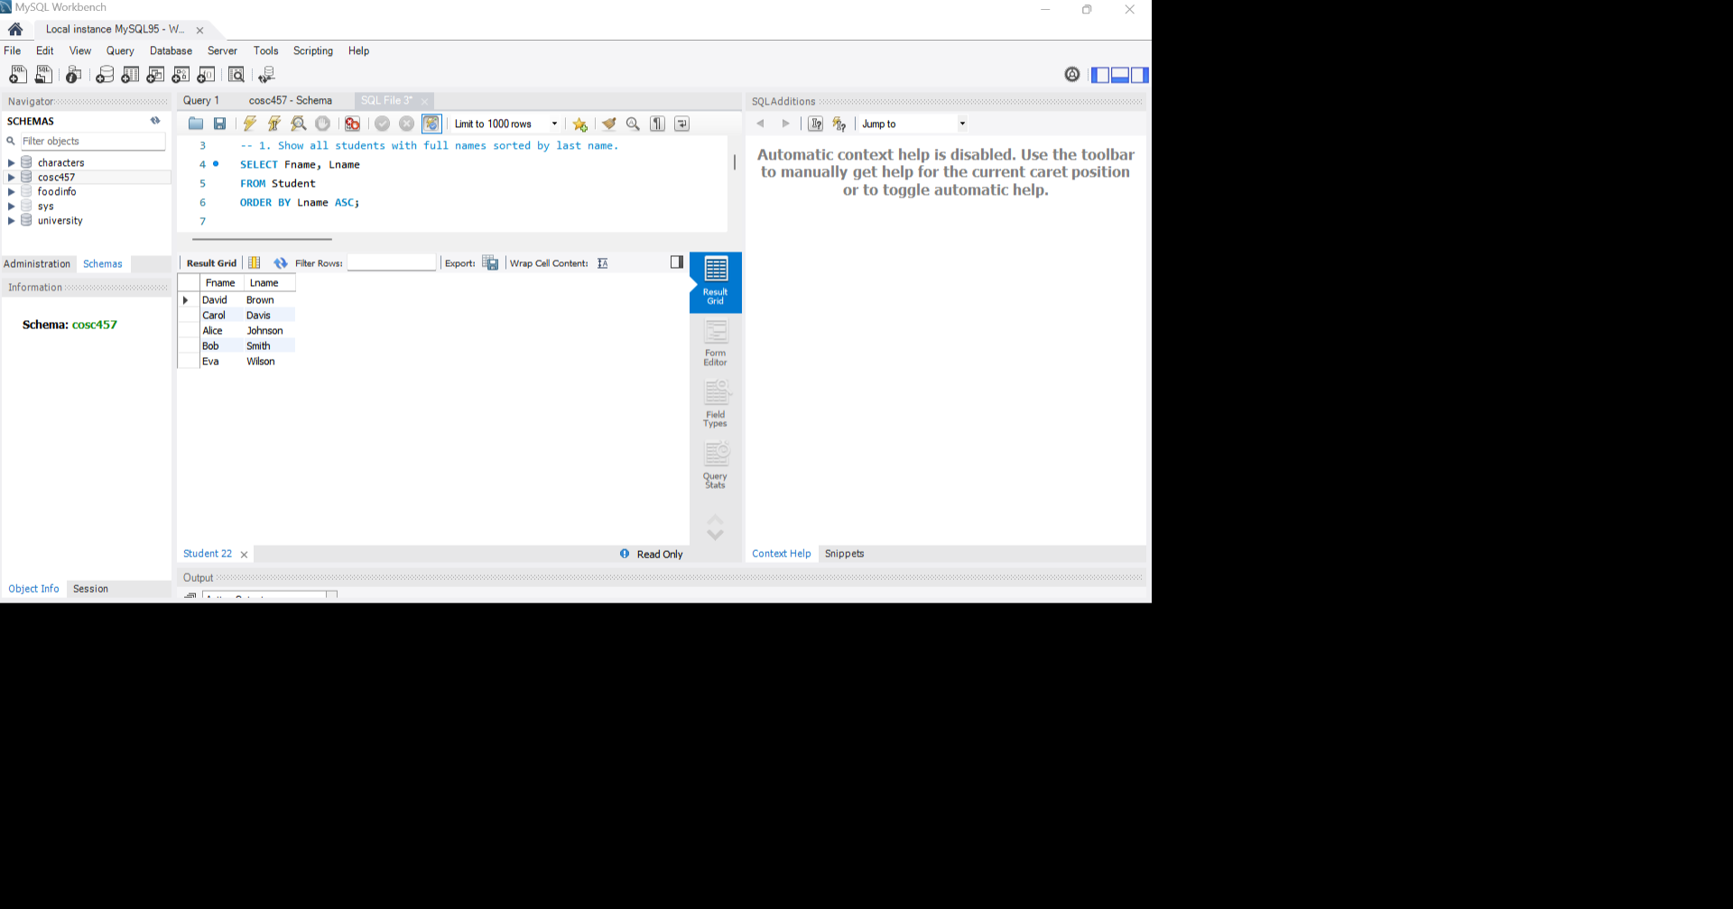
- Show students in Year 2 or higher.
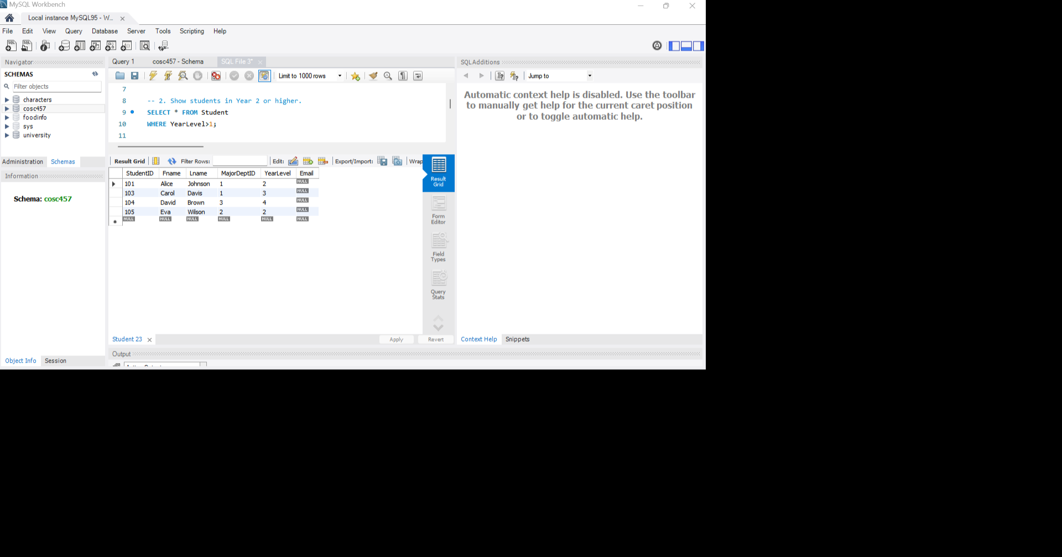
- Show student names with their department names
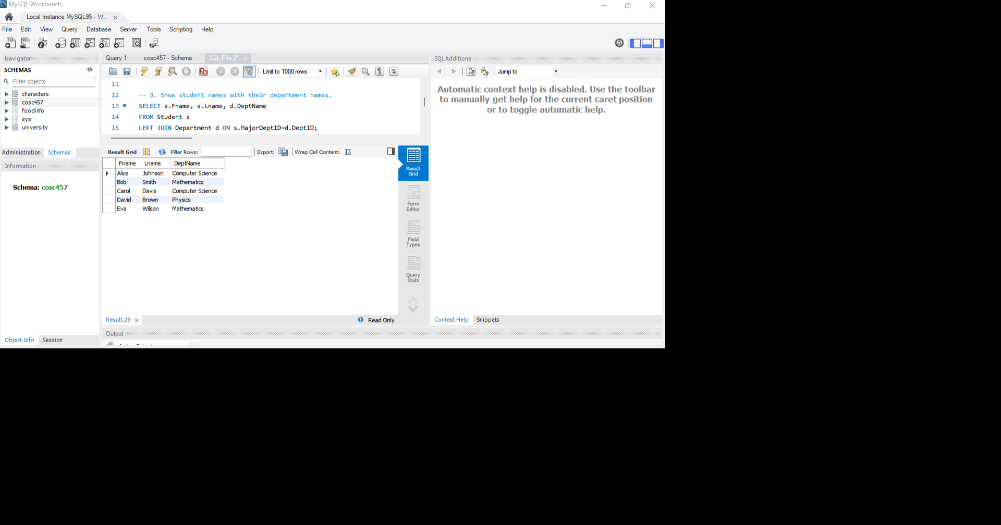
- Count number of students in each department
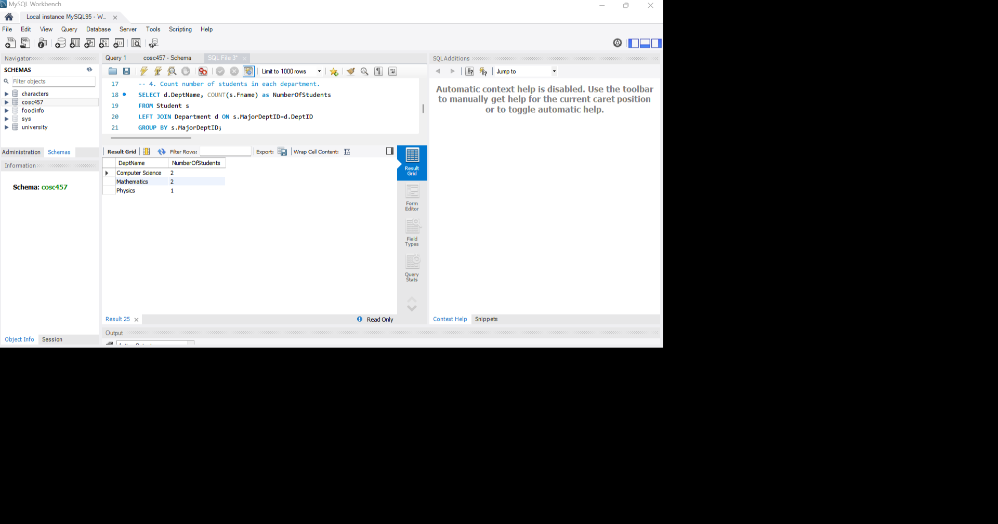
- Add a column 'Email' to the Student table
